**152-080 Databases**

# **Unit 9: Stored Procedures**

# Introduction

In this lab you will create Stored Procedures. In order to do this assignment, you will need to run statements against the Education database you created in Unit 9.

If you don’t have the Education database, run the U12_*Education.sql* script to create the database **Education** and all the tables and data to complete this assignment**.**

The ERD below shows all the tables and their relationships in the **Education** database.

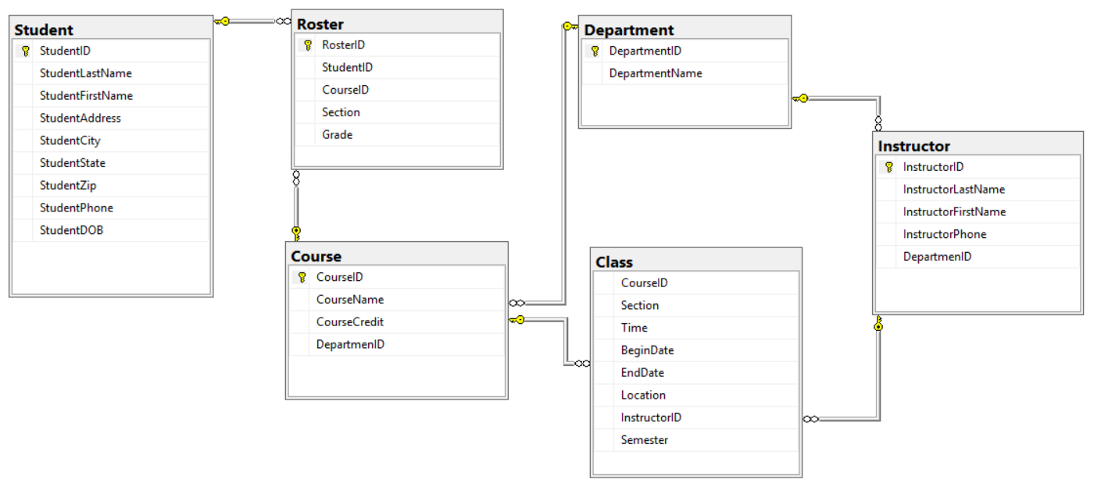

# Instructions

You are to complete the following actions. In order to do this assignment, you will need to run statements against the Database you created named **Education** in Unit 9. For each question below – paste in print screens of your progress in each step.

1. Create the stored procedure named **sp_InsertClass** below which will work with the **Education** database. Create the procedure below in SQL Server. (10 pts)

USE Education

GO

CREATE PROCEDURE sp_InsertClass

@pcid VARCHAR(7),

@psection VARCHAR(3),

@ptime VARCHAR(10),

@pbegindate DATE,

@penddate DATE,

@plocation VARCHAR(4),

@piid INT,

@psemester VARCHAR(6) = "201302"

AS

INSERT INTO dbo.class (CourseID, Section, Time, BeginDate, EndDate, Location, InstructorID, Semester)

VALUES(@pcid, @psection, @ptime, @pbegindate, @penddate, @plocation, @piid, @psemester);

GO

**Your Print Screen:**



2. Insert a row by executing the procedure (see code below). (5 pts)

USE Education

GO

EXEC sp_InsertClass '107114', '001', '18000000', '20130905', '20131212', 'L208', 772

GO

**Your Print Screen:**



3. Now let’s modify the stored procedure to add error catching. (10 pts)

USE Education

GO

ALTER PROCEDURE sp_InsertClass

@pcid VARCHAR(7),

@psection VARCHAR(3),

@ptime VARCHAR(10),

@pbegindate DATE,

@penddate DATE,

@plocation VARCHAR(4),

@piid INT,

@psemester VARCHAR(6) = "201302"

AS

BEGIN

DECLARE @Error INT;

INSERT INTO dbo.Class (CourseID, Section, Time, BeginDate, EndDate, Location, InstructorID, Semester)

VALUES(@pcid, @psection, @ptime, @pbegindate, @penddate, @plocation, @piid, @psemester);

SET @Error = @@ERROR;

IF @Error = 0

PRINT 'New Class Section Added';

ELSE

BEGIN

IF @Error = 547 -- FK violation

PRINT 'Sorry you violated a FK integrity check on either Course ID or Instructor ID'

ELSE -- something unknown happened

PRINT 'Unknown error occurred.';

END

END

GO

**Your Print Screen:**

4. Now let’s try to insert a row - run the statement below. (5 pts)

USE Education

GO

EXEC sp_InsertClass '107114', '001', '18000000', '20130905', '20131212', 'L208', 772

GO

**Did it work? Why or why not?**

It did work because no Error messages were triggered



5. Now let’s try to insert another row – run the statement below. Did it work and why? (5 pts)

USE Education

GO

EXEC sp_InsertClass '107114', '001', '18000000', '20130905', '20131212', 'L208', 779

**YOUR ANSWER**:

It did not work because there was a confliction with a foreign key constraint.

6. Insert one more row. (5 pts)

USE Education

GO

EXEC sp_InsertClass ‘001’, ‘18:0000:00’, 20130905, ‘20131212’, ‘L208’, 772

**Did it work? Why or why not? If there’s any error, find it, fix it, and have it run.**

It did not work because it was missing a number in the insert and it could not convert a varchar to a date.

7. Create a stored procedure to insert a new row into the Instructor table. Make sure to use parameters for the values so it will be very reusable and paste your stored procedure below – make sure to include error checking. (25 pts)

**YOUR COMMAND WAS**:

8. Execute the stored procedure to insert in the following record – paste a print screen of the result of the insert and also of a SELECT * FROM Instructor; (5 pts)

Instructor ID=723

Instructor Last Name = Hur

Instructor First Name =Christian

Instructor Phone = 262-619-6388

Instructor Department = 3

**YOUR ANSWER**:

9. Create a stored procedure to update the phone number of an existing row in the Instructor table. Use parameters for the Instructor ID and the Phone number which need to be changed so as to make it very reusable. Paste your stored procedure below – make sure to include error checking. (25 pts)

**YOUR COMMAND WAS**:

10. Execute the stored procedure to UPDATE the following record – paste a print screen of the result of the update and also of a SELECT * FROM Instructor; (5 pts)

Instructor ID=723

Instructor Last Name = Hur

Instructor First Name =Christian

Instructor Phone = 262-619-6280

Instructor Department = 3

**YOUR ANSWER**:

